Visualizing and Predicting Heart Diseases with an Interactive DashBoard

# Team ID : PNT2022TMID28787

# Team Size : 4

# Team Leader : JENNA JODLY S

# Team member : NIVEDHA E

# Team member : KALAIVANI V

# Team member : KAVIYA R

# PROBLEM STATEMENT:

The major cause of death in the developed world is heart diseases. To analyse and predict which patients are most likely to suffer from heart dieases in the near future we have to find out some solution.

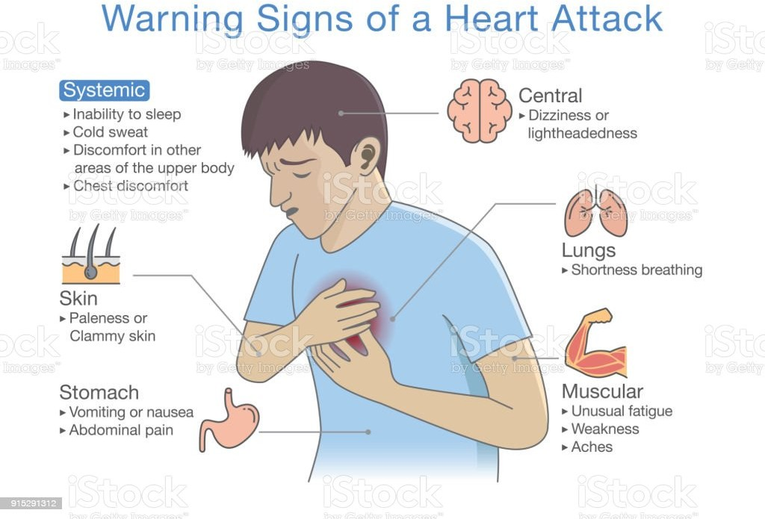

# IDEA /SOLUTION DESCRIPTION:

So for the above mentioned problem statement,we can create or develop a interactive dashboard of visualizing the people who might have the possiblities are high chances of getting CardioVascular Diseases(CVD) through a collection of dataset.

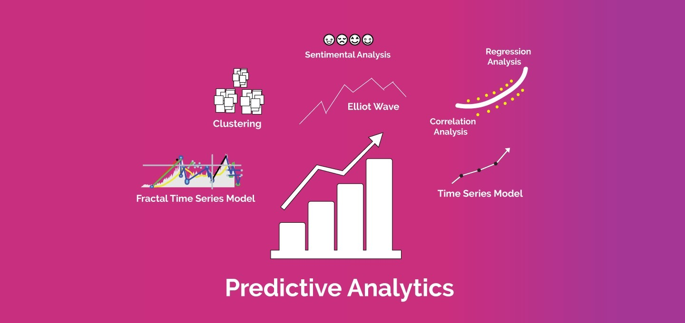

# NOVELTY /UNIQUENESS:

Most of all heart diseases can be identified and treated using ECG in medical field,and the theory of curing can be in handwritten and they get research to it and finally implement it in practical.But in modern technology world we can predict and able to prevent the diseases through a visualization of people who can get caught by heart diseases through data analytics.By this, we can create awareness among people who are all at the high risk of getting CVD. This make a way easy to Doctors and it consumes time for them.

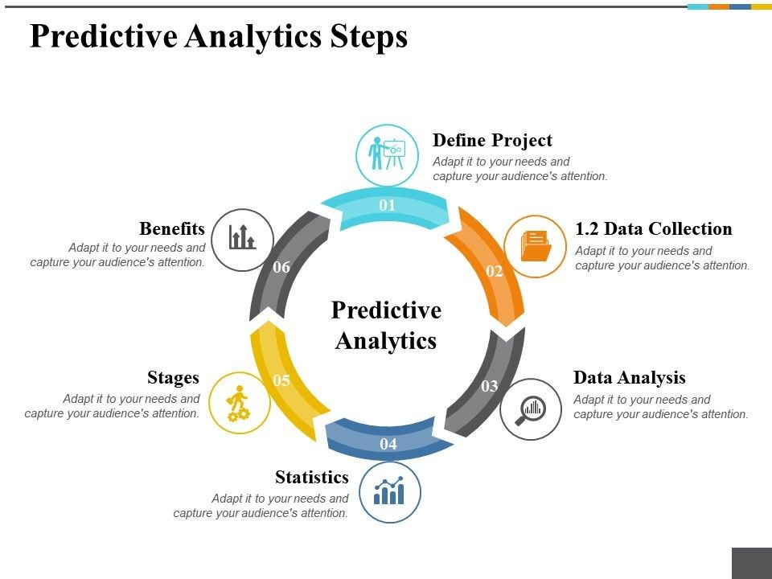

# SOCIAL IMPACT/CUSTOMER SATISFACTION:

By using this method,we can separate the people those who can affected vs normal people,and it will play a vital role combining both medical and technology field.

Customer(patients) can get benefit through saving financial cost (spending medical test),and by collecting dataset of their detailed condition,we can say that whether they get affected or not. This makes oldage people travel less, and get results from their comfort zone.

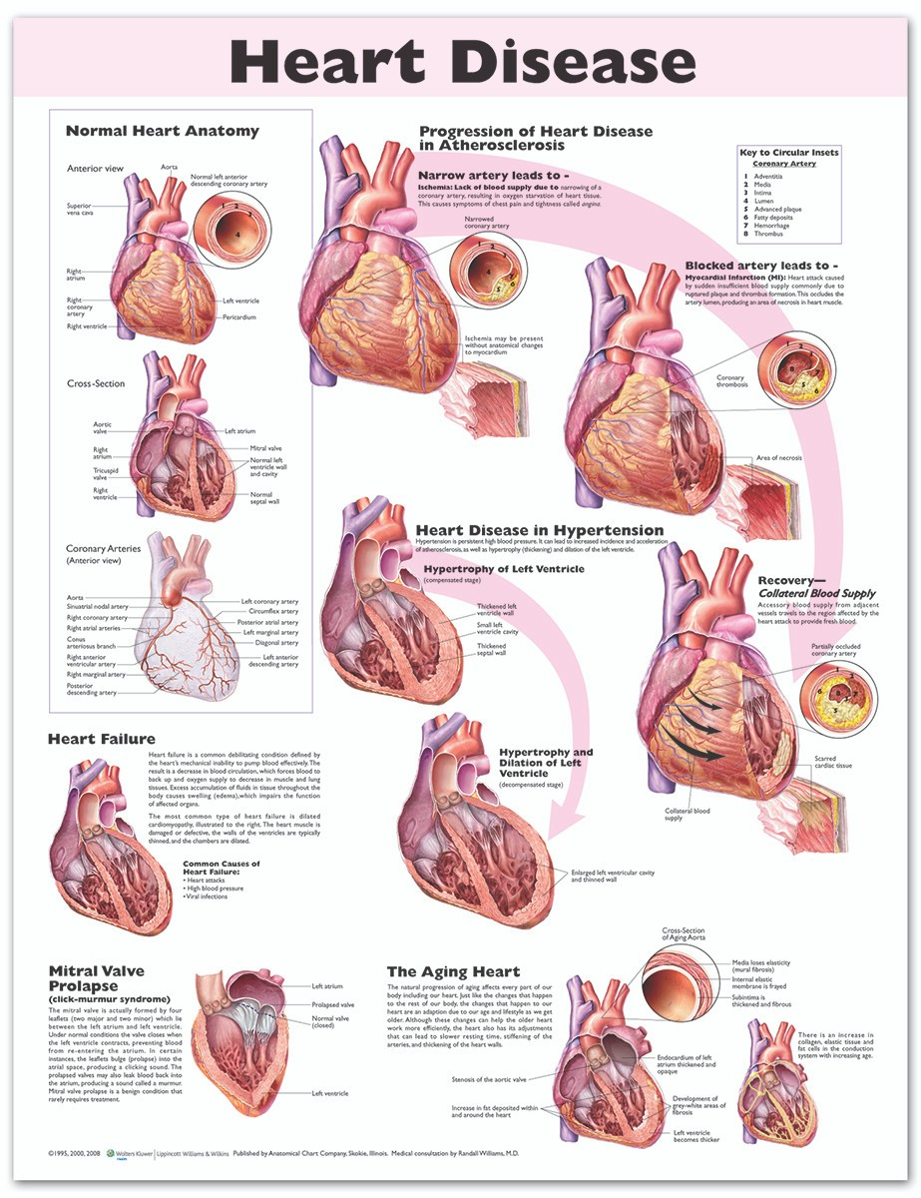

# BUSINESS MODEL(REVENUE MODEL):

We can make revenue from this by making our developed model or a product form which can be modified into software kit, application or a webpage where they can interact easily. This all comes and developed under data analytics. We can get profited by selling or giving access with permission to our clients(Doctors).

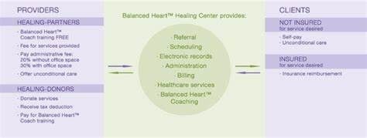

# SCALABILITY OF THE SOLUTION:

It is based on the number of users who maintaining the software or a system according to its performance like work flow, increase or decrease in efficiency, response time etc... Its scalability can be measured by maintanence, checking for software,fixing errors if occured in server. By this a good quality of product is determined. If you suffer from a heart condition that interferes with your ability to work, you may qualify for **disability benefits**. There are a number of heart conditions that are specifically listed by the Social Security Administration as qualifying conditions. These conditions include chronic heart failure, ischemic heart disease, recurrent arrhythmias, hypertensive heart disease, an individual on the waiting list for a heart transplant or a heart transplant recipient, and more.

